Complications of removing wisdom teeth
Wisdom teeth removal is a specialist treatment provided by Oral Surgeons. Oral Surgeons are dentists who have further specialised in the surgical aspects of dentistry. The removal of wisdom teeth is the most commonly requested treatment.
Wisdom teeth themselves are simply the last teeth to erupt into the mouth usually in the late teens or early twenties. Because of this delayed eruption there is often very little space for the wisdom teeth by the time they attempt to erupt into the mouth. For this reason they are usually unable to erupt fully into the mouth. They often are effectively pushed around and will often erupt at unusual positions at the back of the mouth. This makes the wisdom teeth difficult or impossible to clean, resulting in caries and repeated infection around the tooth.

For the above reasons wisdom teeth are often removed. Fortunately most wisdom tooth removal procedures are uncomplicated procedures with few side effects. However may complications do occur and no matter how rare when they happen to you they can be distressing.

Prolonged bleeding after the removal of wisdom teeth is normally due to surgical trauma, often combined with an infected surgical site which increases the blood supply to an area. This bleeding can be controlled with local measures such as rest and applying pressure to the surgical site.

Serious prolonged bleeding may be due to an undiagnosed defect in the patients clotting mechanism and needs to be referred to a haematology unit for correct diagnosis and treatment.

Post-operative infection is a common complication. Many wisdom teeth are infected when the patients presents for an extraction. This infection can be controlled with local measures such as rinsing with hot salty water and corsodyl mouth wash. Systemic measures such as antibiotics are invaluable. Antibiotics should be used selectively to control dental infection as over prescribing will reduce the effectiveness of antibiotics.

The best known complication of wisdom tooth extraction is a prolonged numb or pins and needles in the lower lip, chin and or tongue. This is because the nerve to your lower lip, chin and tongue runs under and close to the roots of your teeth. The incidence of numb lip is one in every 200 patients. This usually resolves within 6 months, however it will occasionally take up to 18 months for the altered sensation in the lower lip to resolve. On very rare occasions the removal of wisdom teeth will cause a permanent numb feeling in the lip, chin or tongue. It is impossible to predict who will suffer this complication and there is no effective treatment for a numb lip after wisdom tooth removal.

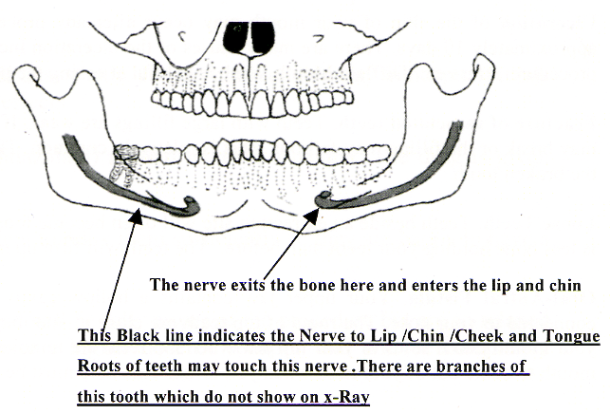

Dry socket is not really a complication of wisdom tooth removal; it’s more an unpleasant side effect. But is included here due to its distressing symptoms. An intense pain which begin about 3 days after the extraction of the wisdom tooth. The pain is immune to analgesics and is not influenced by antibiotics. The pain is constant, will disturb your sleep and will make normal daily functions impossible. The pain typically lasts 10 to 14 days before resolving. On rare occasions the pain may last much longer. The only effective treatment is to keep your mouth as clean as possible with hot salty water and corsodyl mouth washes. Once the symptoms resolve the sockets will heal as normal.

Fracture of associated teeth is a common complication. Wisdom teeth are difficult to clean. Food and bacteria will often accumulate around wisdom teeth resulting in decay in the teeth associated with wisdom teeth. By the time a patient presents for wisdom tooth removal the tooth in front of the wisdom tooth is frequently heavily restored or carious. These teeth are compromised and weak. The fracture of these teeth when the wisdom tooth is removed is a common and often unpredictable and unavoidable complication. This may result in the associated tooth being extracted or requiring a root canal treatment and crown.

Ulceration of the mucosa surrounding wisdom teeth is another relatively common complication. The ulcers are normally superficial and heal within 10 days. They can however be quite painful and make eating difficult. The causes of ulceration are varied. Stresses associated with the procedure, biting or chewing of the cheek while it is numb and trauma from the surgical extraction itself is the usual causes.

The other complications are thankfully much less common and include
- Swallowing of portions of teeth, these will normally pass through you without problems.
- Inhalation of teeth or teeth fragments is an extremely rare complication and possibly the worst possible complication as the teeth will need to be removed from the lungs.
- Fracture of the jaw or portions of the jaw is in fact a relatively common complication; however the fractures are normally of small portions of bone and will heal without incident. A complete fracture of the jaw is a rare event.
- Jaw joint dysfunction is an unpleasant complication. These results from the disc of cartilage in your jaw joint becoming displaced while your mouth is open for the extraction. There is no guaranteed long term fix for this complication. The symptoms of pain, clicking jaw and lock jaw may persist on an irregular basis for the rest of your life.
- Persistent pain from the extraction is a rare but recognised complication. The cause is unknown but symptoms of un-treatable and un-resolvable pain from the extraction site can be extremely distressing.
It is impossible to compile an inexhaustible list of all possible complications. Anything that can possibly go wrong will in time go wrong. Any oral surgeon who works on a regular basis will continue to see new and rare complications which must be resolved as they arise. The above list covers 99.9 % of complications. When you suffer complications you should contact your oral surgeon for further assistance and advice.

