Teeth and Roots Displaced into the Maxillary Sinus
There is a hollow cavity in your cheek bone. The cavity is called a Sinus. The Sinus cavity is connected by a small opening to your nasal cavity. The roots of your top back teeth are all close to the Maxillary Sinus. Sometimes the roots of your top teeth will be inside the maxillary sinus. This can result is a side effect of roots or whole teeth falling into the maxillary sinus during dental extractions. This also results in the creation of a hole (an oro antral fistula or OAF) which connects your mouth to the hollow maxillary sinus and then on to the nasal cavity.
This situation has to be corrected as fluid and infection can pass into the maxillary sinus. The tooth must be removed and the hole (oro antral fistula) connecting the mouth and maxillary sinus closed. The tooth is usually removed by enlarging the hole (oro antral fistula) into the maxillary sinus to allow retrieval of the tooth. The bony hole is then closed by stitching a large flap of gum over the hole.

When the flap of gum heals there will be a soft tissue layer of gum closing the bony hole (oro antral fistula) With time bone will grow across the hole and a bony layer is produced.
Closure of the oro antral fistula will cause quiet a degree of bruising and swelling in your face between your eye and upper lip. A black eye is very common. Several non dissolvable sutures will be in your mouth and you will need a course of anti-biotics and painkillers for several days. Keeping your mouth clean by the use of warm salty water mouth washes and Corsodyl mouth wash is even more important to ensure good and rapid healing.
Probably the most important factor in determining healing is smoking cigarettes. If you continue to smoke during the healing period it is almost guaranteed that there will be no healing and the hole will remain open.
If a oro antral fistula fails to close, attempts must be made to close it again. Each subsequent attempt to close an oro-antral-fistula is more difficult than the previous. So it is important to aim for healing at the first attempt.

This x-ray below shows an upper right 3rd molar (wisdom Tooth ) which has been displaced into the cavity of the maxillary antrum during an attempted extraction.

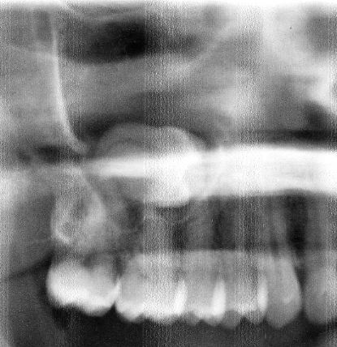

The x- ray below shows a rectangular white object, the root of a tooth which has been displaced into the maxillary antrum on the left hand side during an attempted extraction.
